INDUSTRIAL ENGINEERING DEPARTMENT
Subject: Engineering Mechanics Time Allowed: 2 hours
Year: 2015 Maximum Marks: 40

Question 1: The press shown is used to emboss a small seal at E. Knowing that P = 250 N, determine (a) the vertical component of the force exerted on the seal, (b) the reaction at A.
Question 2: Determine the force in members CD and DF of the truss shown.
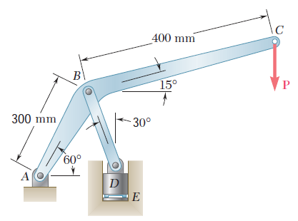 | 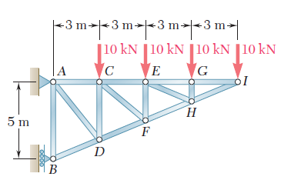
Question 1 | Question 2

Question 3: The rigid L-shaped member ABC is supported by a ball-and-socket joint at A and by three cables. If a 8-kN load is applied at F, determine the tension in each cable.
Question 4: The frame shown supports part of the roof of a small building. Knowing that the tension in the cable is 150 kN, determine the reaction at the fixed end E.

Question 3 | Question 4

